**Introduction:**

**\*Introduction to Estimation of Business Analysis Using Tableau\***

**Business decisions, more than ever, are driven by a blend of historical data and predictive insights. In this landscape, the need to transform raw numbers into actionable strategies is paramount. Tableau, renowned for its superior data visualization capabilities, has been instrumental in our endeavor to estimate various facets of our business operations.**

**This report showcases the utilization of Tableau in representing both past trends and future estimations. While the historical data paints a picture of our journey, the estimations, derived from rigorous analytical methods, illuminate the potential paths ahead. From sales forecasts to operational cost predictions, our Tableau visualizations provide a comprehensive, at-a-glance view of where we stand and where we might be heading.**

**In navigating the intricate maze of business analysis, the clarity offered by these visualizations serves as both a compass and a roadmap, guiding our decisions and strategies for the future.**

**Purpose:**

**This report leverages Tableau to visually represent our business's past performance and future estimations. Through detailed visualizations, we aim to offer stakeholders a clear understanding of our operational trends and projected outcomes, assisting in informed decision-making for strategic growth.**

**Problem definition &design thinking**

**Empathy map**

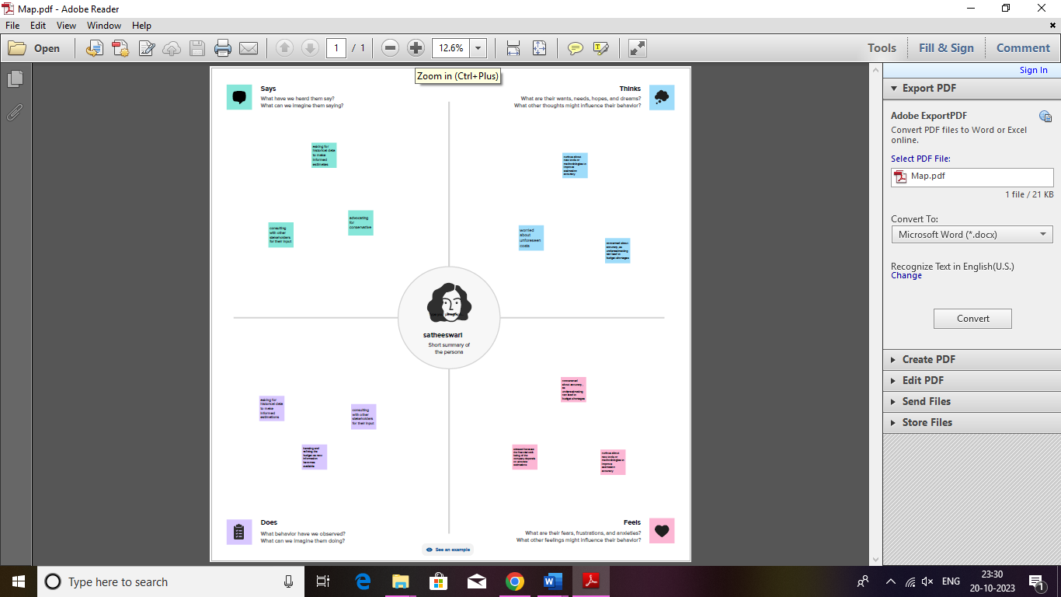

**Ideation& brainstorming**

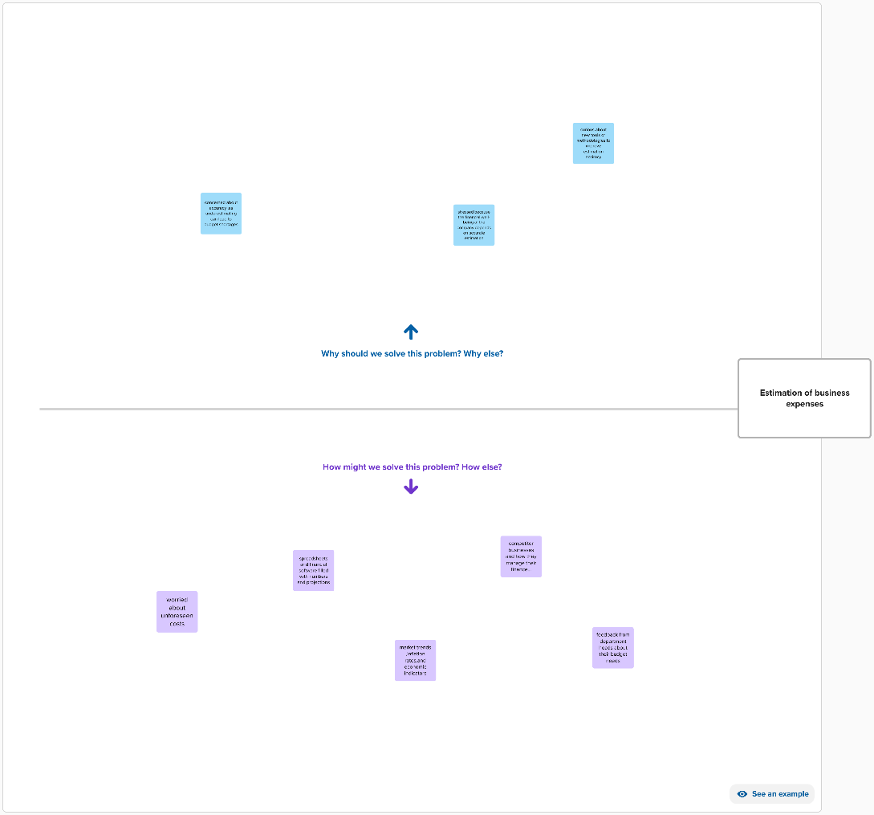

**Data Set**

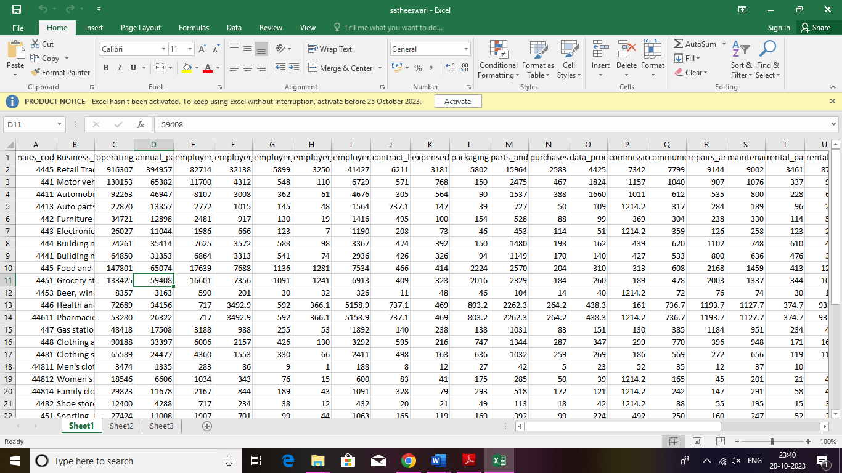

**Tableau**

**Dsahboard**

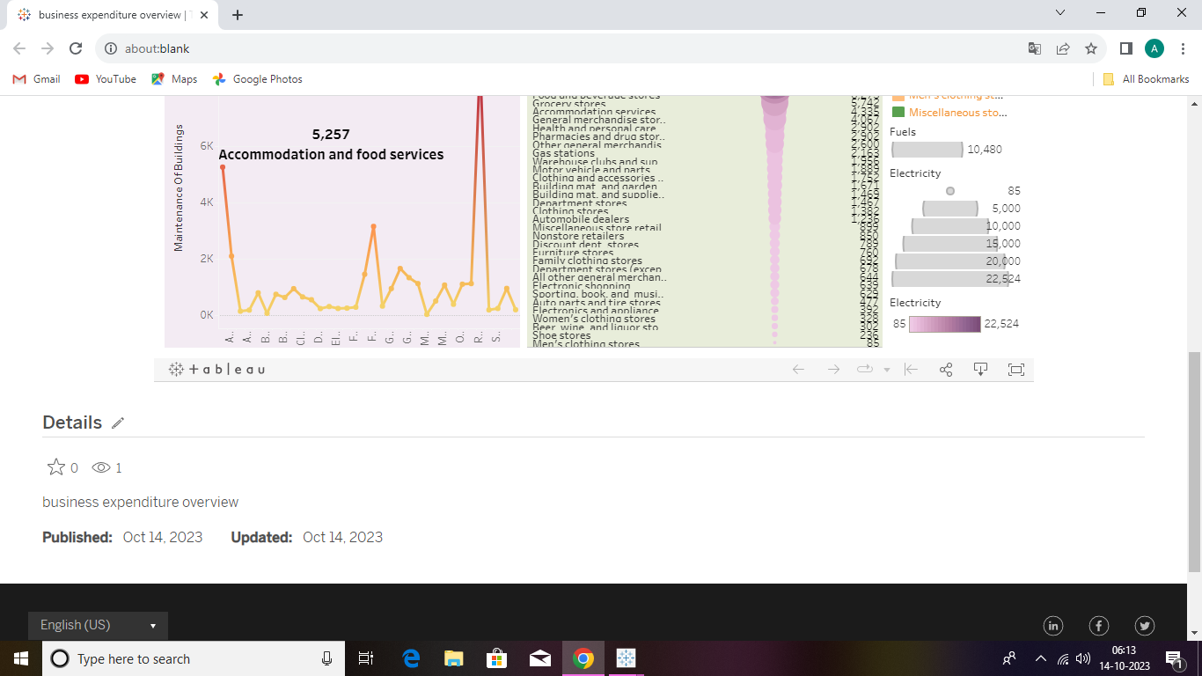

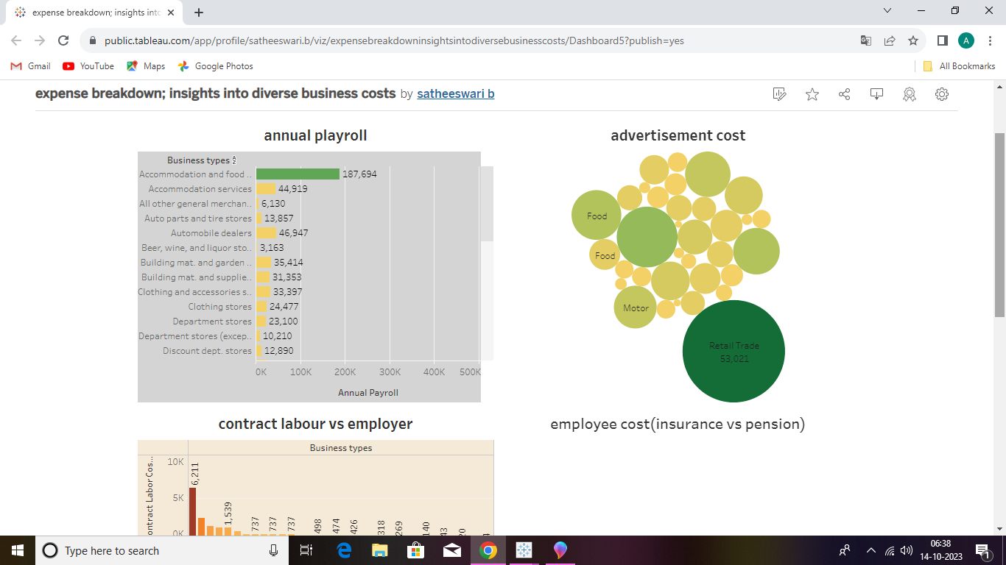**t**

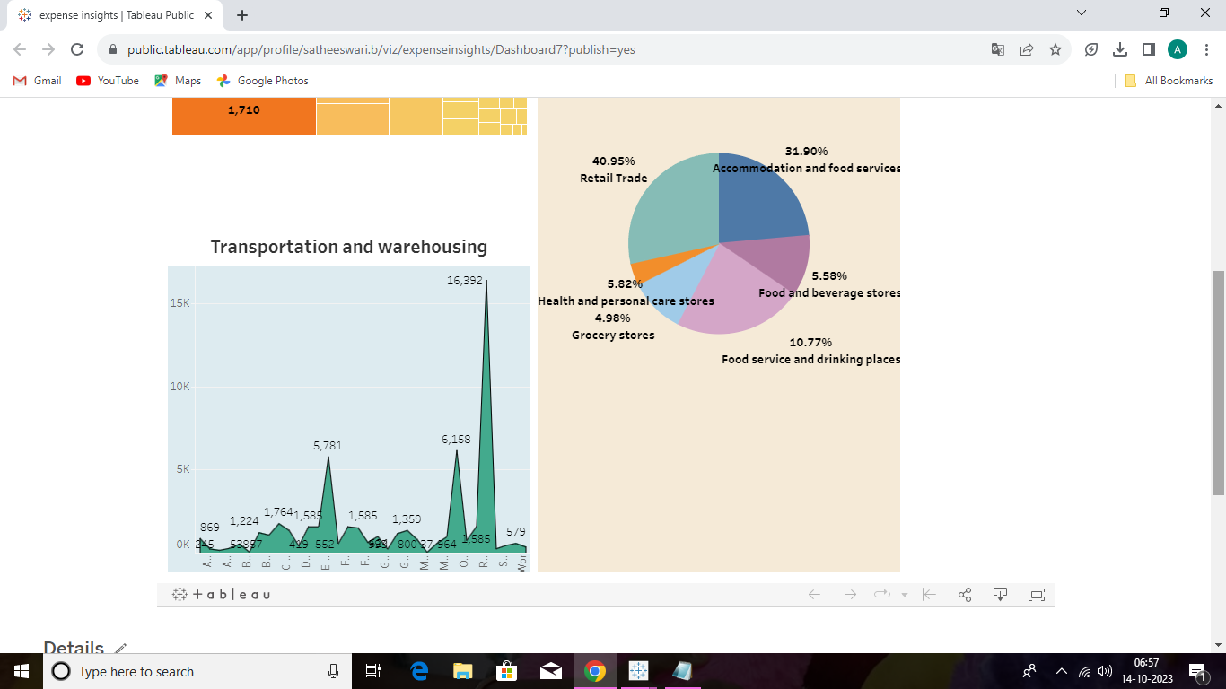

**Story**

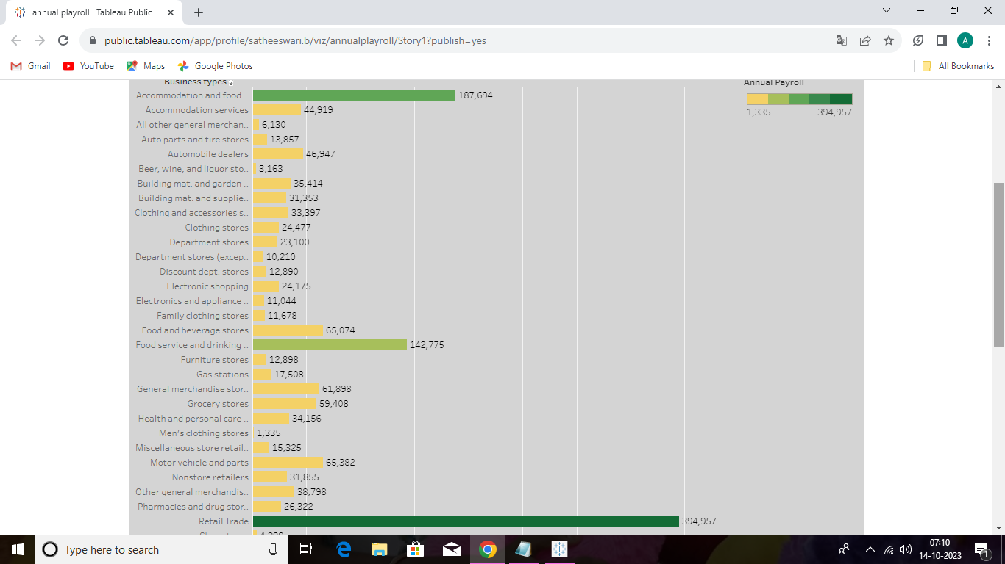

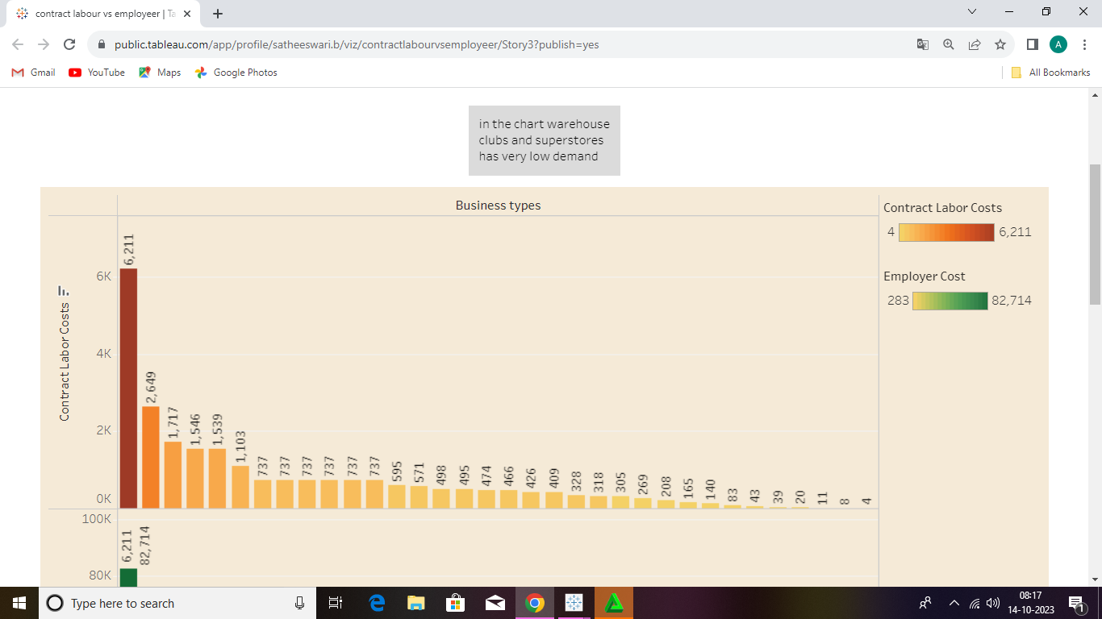

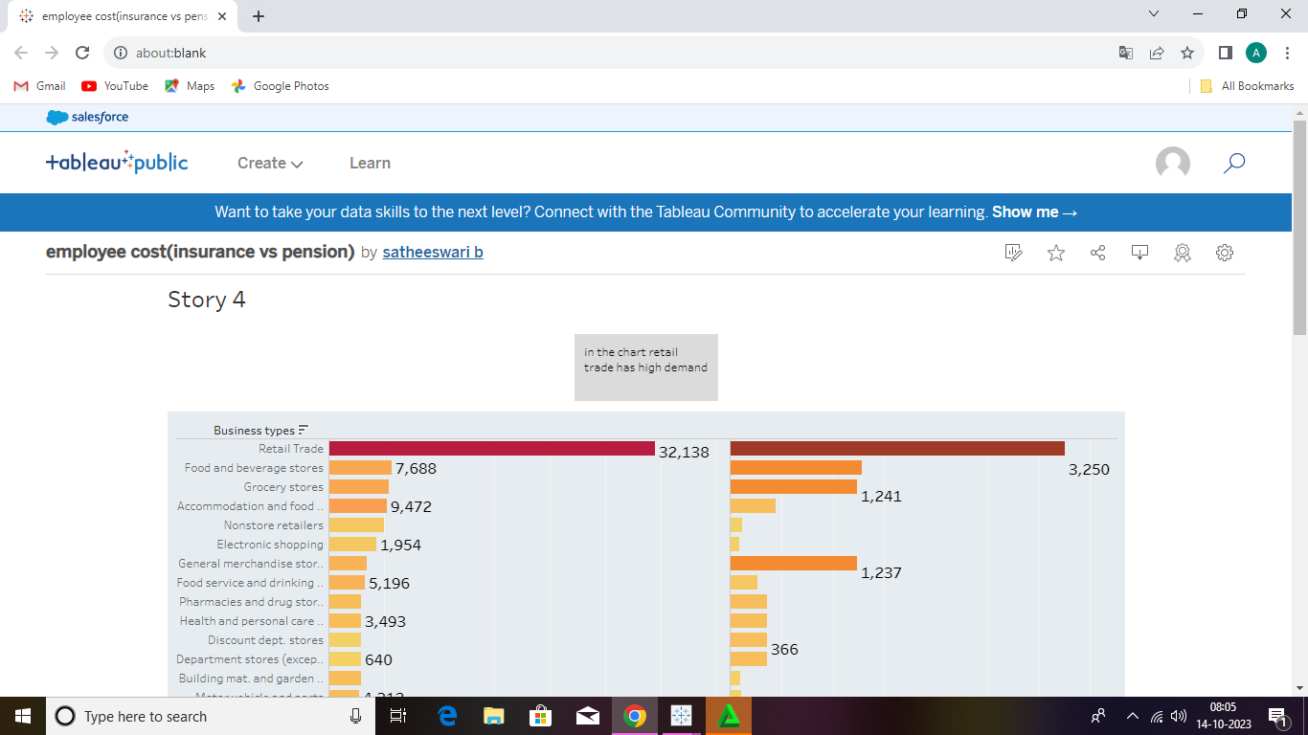

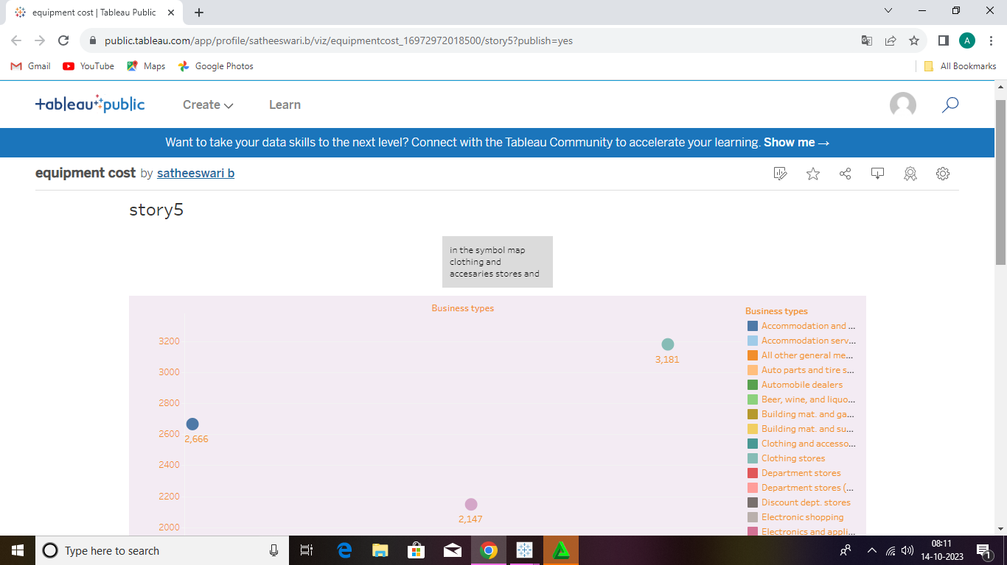

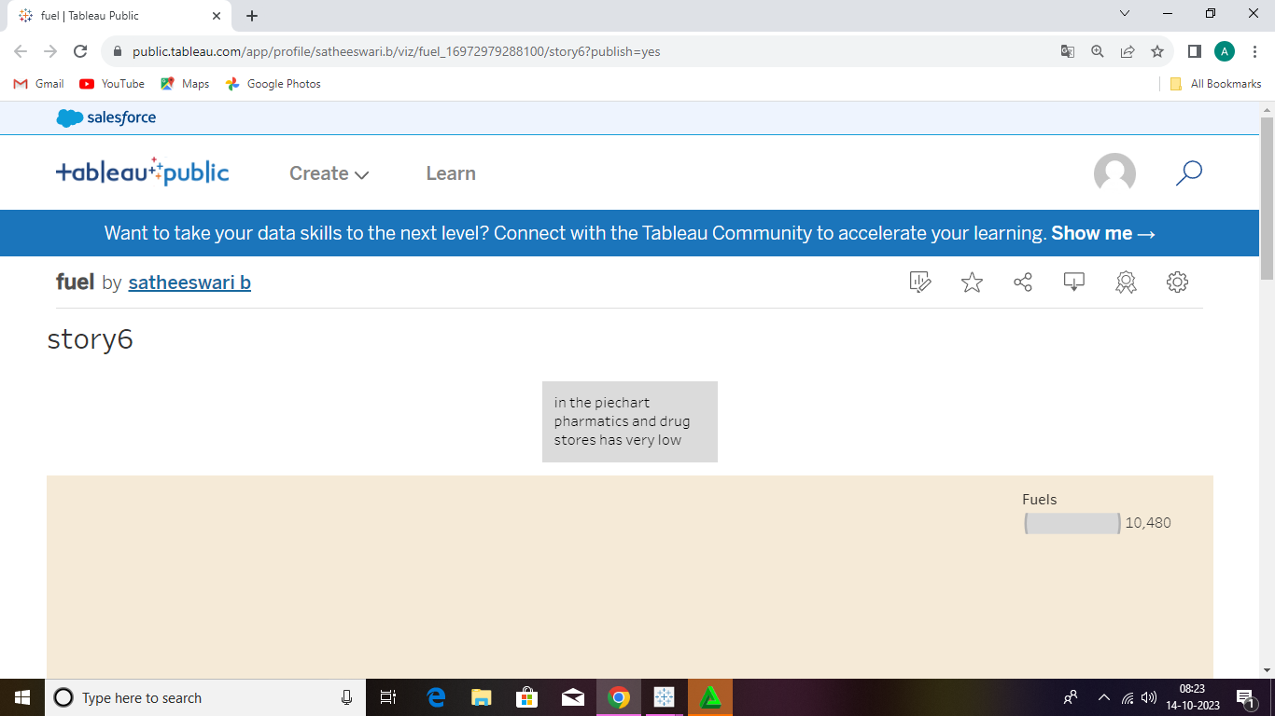

**Publish**

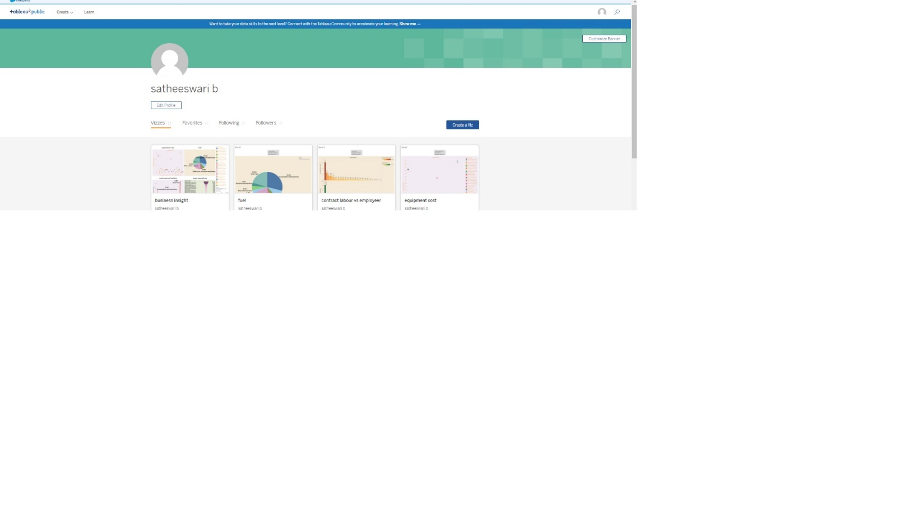

**Advantage**

**1. *Intuitive Visualizations*: Transforms complex data into easily digestible visuals.**

**2. *Data Integration*: Seamlessly combines data from multiple sources.**

**3. *Real-time Insights*: Offers up-to-date analytics for swift decision-making.**

**4. *Customizability*: Tailors dashboards to specific business needs.**

**5. *Collaborative Platform*: Enables shared access for team-wide insights**

**Disadvantages**

**1. *Learning Curve*: Requires time and training for effective utilization.**

**2. *Cost Factor*: Premium features come at a higher price point.**

**3. *Performance Issues*: Handling extremely large datasets can be slow.**

**4. *Advanced Analysis*: Limited capabilities for complex statistical analysis.**

**5. *Integration Challenges*: Not all third-party tools sync seamlessly.**

**\*Conclusion*:**

**Tableau has proven to be a formidable tool for visualizing business analysis estimations, transforming intricate data into actionable insights. While its strengths in data visualization and integration are commendable, potential users must also consider its learning curve and other limitations. Ultimately, when wielded effectively, Tableau can be a cornerstone in data-driven decision-making, fostering informed strategies for future business growth.**

**\*Future Scope*:**

**As data-driven decisions become the norm, Tableau's role in business analysis is poised to expand. Future advancements may encompass AI-powered predictive analytics, deeper integration with diverse data sources, and more user-friendly interfaces for non-technical users. This progression will likely enable businesses to extract richer insights, optimize operations, and anticipate market shifts more accurately.**